 | METROLOGY AND MEASUREMENT SYSTEMS  Index 330930, ISSN 0860-8229  www.metrology.pg.gda.pl | 
GUIDELINES FOR THE PREPARATION OF PAPERS FOR THE JOURNAL METROLOGY AND MEASUREMENT SYSTEMS

Hans-Dieter Schmidt¹⁾, Jan Kowalski²⁾
1) Institut für Oenologie und Getränketechnologie, Weinstraβe 24, D-08345 Reinsberg, Germany (hdschmidt@iog.com.de)
2) Warsaw University of Technology, Faculty of Electronics and Information Technology, Institute of Radioelectronics, Nowowiejska 15/19,
00-665 Warsaw, Poland ( j.kowalski@abc.pw.edu.pl, +48 22 432 7721)

Abstract
This document provides guidelines for preparing manuscripts accepted for publication in the journal Metrology and Measurement Systems. The body text of each manuscript should be preceded by an abstract limited not exceeding 10 lines, printed using the font size of 10 pt, followed by 3–6 keywords.
Metrology and Measurement Systems is a peer-reviewed, quarterly-published journal, launched in 1988; since 2001 it appears in English. It is devoted to the publication of papers on research, development and applications in the field of measurement science and technology. It is included in the Thomson-Reuters Master Journal List; it is also indexed and abstracted by INSPEC, Scopus, Index Copernicus, and Google Scholar. The journal appears both in the paper form and in the electronic form on the platform MetaPress. Abstracts and full texts of all papers are available on the journal website: www.metrology.pg.gda.pl

Keywords: spectrophotometry, chemometrics, spectral data processing, food analysis.

© 2017 Polish Academy of Sciences. All rights reserved

1. Introduction

The following types of papers are published in Metrology and Measurement Systems:
- invited review papers presenting the current stage of the knowledge (max. 20 edited pages, 3000 characters each),
- research papers reporting original scientific or technological advancements (max. 12 pages),
- papers based on extended and updated contributions presented at scientific conferences (max. 12 pages),
- short notes, i.e. book reviews, conference reports, short news (max. 2 pages).
The text of a manuscript should be written in clear and concise English. The camera-ready format – with an attached separate file containing illustrations, tables and photographs – is preferred. For the details of that format, authors should consult the sample article, available on the journal website (www.metrology.pg.gda.pl).
In the starting section (usually called “Introduction”) the problem under study should be described and positioned with respect to the state of the art by quoting appropriate references. The way of solving the problem and its advantages should also be outlined here.
The following sections represent the main part of the paper. They should contain the description of the used methods and procedures, as well as the presentation of the obtained results of study. The inclusion of examples, illustrating the applications of those results, is recommended.
In the final section, conclusions from the reported research should be provided, in particular – the efficiency of the proposed solutions of the research problem should be assessed and compared with the existing ones (if such solutions exist); the potential. The applications of the results obtained have to be indicated and prospects for future developments outlined.
At the end, a list of references must to be provided.

2. Preparation of manuscript

The main text of a manuscript should be printed on an A4 page (with margins of 2.5 cm) using a font size of 12 pt; the paragraphs should start with the indentation of 5 mm. That text can be divided into sections (numbered 1, 2, ...), first-order subsections (numbered 1.1., 1.2., ...), and – if needed – second-order subsections (numbered 1.1.1., 1.1.2., ...). The title page should include: the manuscript title, authors' names and their affiliations with e-mail addresses. The corresponding author should be identified by the symbol of an envelope and phone number.
The Editor encourages the Authors of submitted papers who are not English native speakers, to use a language service checking the language correctness not only with respect to grammar, but also in the way of presentation of research results accepted by renowned publications e.g. on the website of the European Association of Science Editors (http://www.ease.org.uk/).

2.1. Figures and tables

Figures (illustrations, photographs) and tables, provided in the camera-ready form suitable for reproduction (which may include reduction), should be additionally submitted (one per page), larger than the final size. All illustrations should be clearly marked on the back with the figure number and the author's name. All figures are to have captions. The list of figures captions and table titles should be supplied on a separate page. Illustrations must be produced in black ink on white paper or by computer technique using the laser printer with the resolution not lower than 300 dpi, preferably 600 dpi. The thickness of lines should be in the range 0.2–0.5 mm; in particular cases the range 0.1–1.0 mm will be accepted.

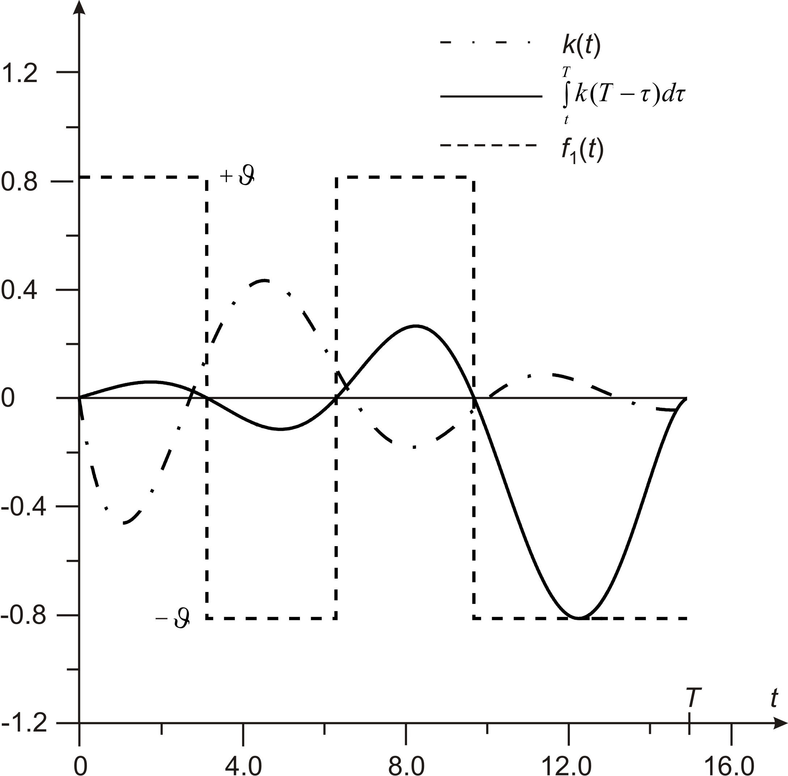

Fig. 1. Exemplary functions $k(t),$$\int_{t}^{T}{k(T−τ)dτ}$ and $f_{1}(t)$.
Original photographs must be supplied as they are to be reproduced (e.g. black and white or colour). Photocopies of photographs are not acceptable.
Figures and Tables should be separated from the text by one free line before and after. The figure caption should be placed below the corresponding figure, the table caption – above the table. A 6-point interspace between the figure and its caption, as well as between the table and its caption is required. The abbreviation “Fig. 1” should be used even at the beginning of a sentence.
Four different exemplary figures and a table are shown here: Fig. 1 – for illustration of special functions, Fig. 2 – for illustration of equivalent schemes, Fig. 3 – for block schemes illustrating the measurement idea, Fig. 4 – for showing result of brake investigation.
Error: Reference source not found
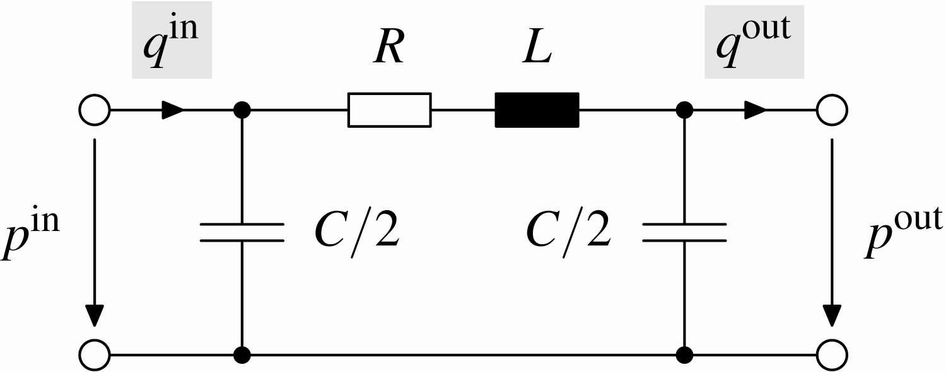  a) π quadripole. | 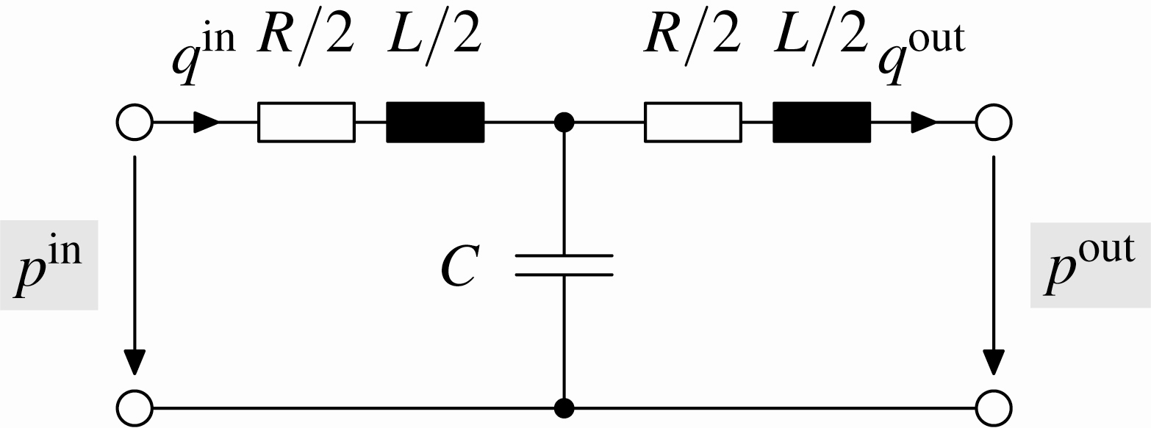  b) T quadripole.

Fig. 2. Discretization of the transmission line.

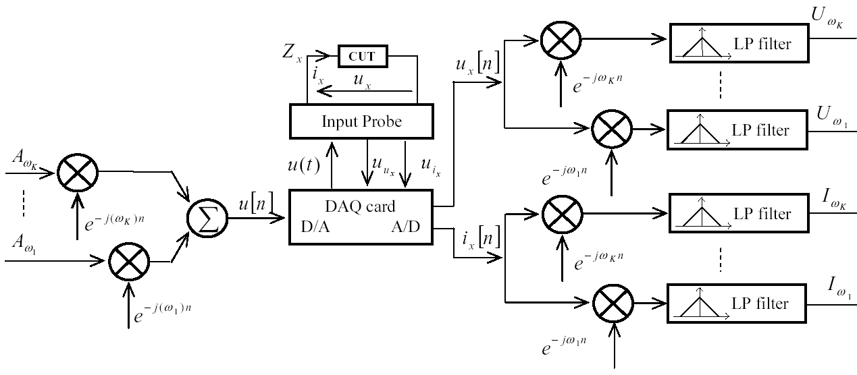

Fig. 3. Illustration of the instrumentation idea.

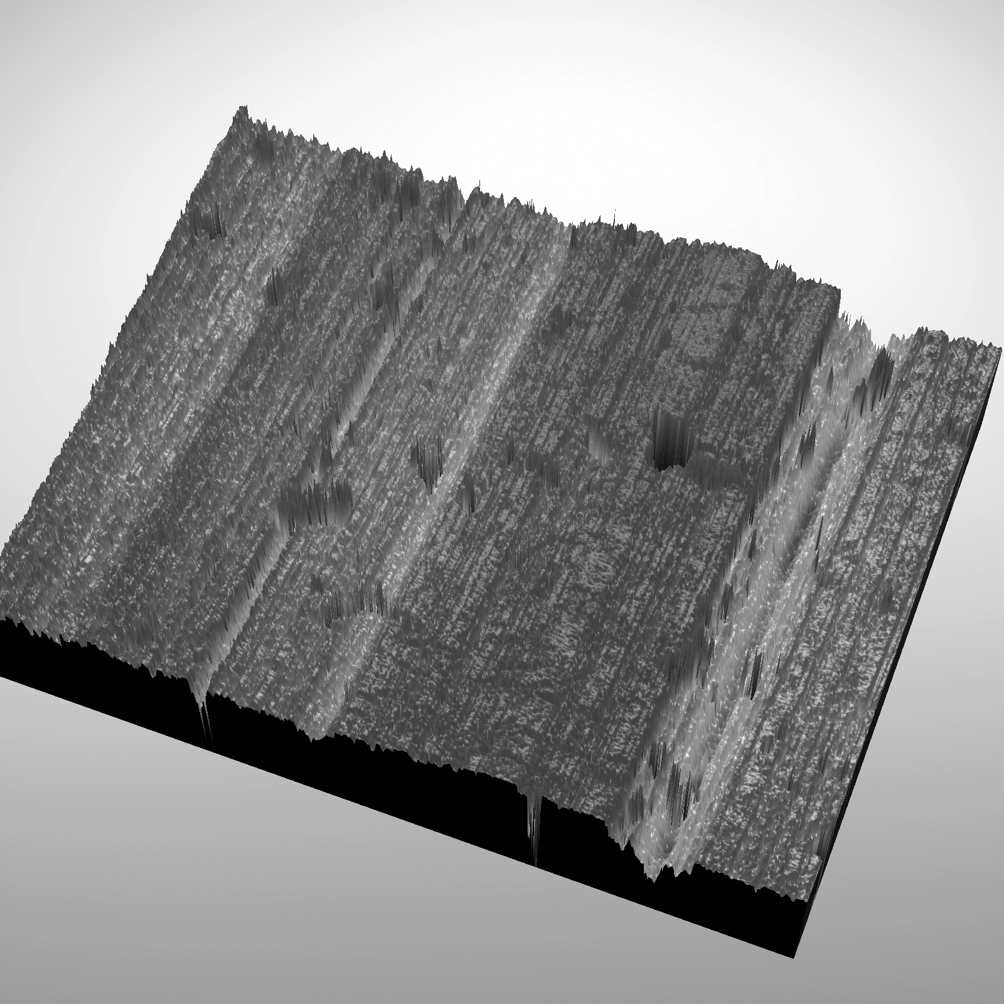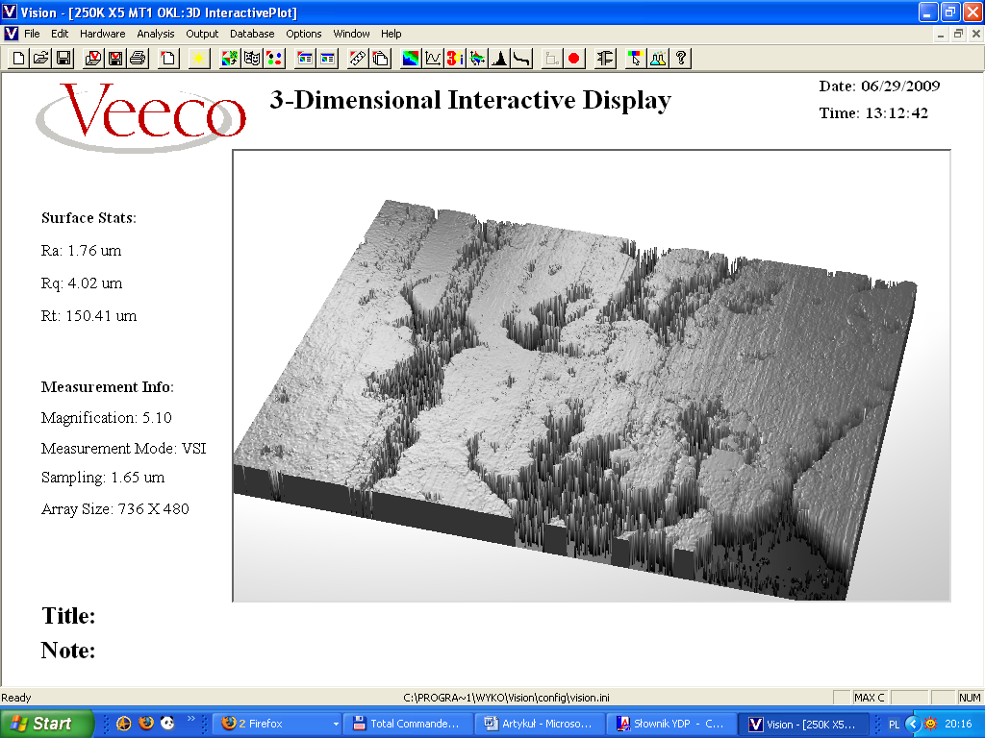

Fig. 4. Brake drum (left) and lining (right) after 250 000 kilometres of covered distance.

Table 1. Results of numerical experiments for stationary and nonstationary filters.

Filter type | $t$ [ms] | $σ_{t}$ [ms] | $e$ [g] | $σ_{e}$ [g]
Stationary, 4th order, $ω_{c}=6\text{.}8π$ | 333 | 46 | –0.015 | 0.06
Nonstationary, 2nd order, $ω_{c}=6\text{.}8π$, $κ=0\text{.}\text{11}$ | 269 | 22 | 0.0 | 0.095

2.2. Equations

All equations must be numbered consecutively throughout the text. Each equation should be preceded and followed by a 6-point spacing. Equation numbers should be enclosed in parentheses and flushed right as below:
$m=\frac{U_{\text{a1}}U_{\text{a2}}(1+α)t}{2{\text{gR}}_{s}(1−ρ_{a}/{ρ_{m}})(z_{u}−z_{l})}\text{.}$ (1)
The type size in the equation is the same as for the text. To make your equations more compact, you may use the appropriate mathematical symbols or expressions.
The symbols used in an equation have to be defined before that equation or immediately follow it. Use “(1)”, not “Eq. (1)” or “equation (1)”, except at the beginning of a sentence where “Equation (1) ...” should be used.

3. References

References should be inserted in the text in square brackets, e.g. [4]; their list, numbered in citation order, should appear at the end of the manuscript. The format of the references should be as follows: for a journal paper – surname(s) and initial(s) of author(s), year in brackets, title of the paper, journal name (in italics), volume, issue and page numbers. The references published in other languages than English shouldn’t be included because of very limited access by the foreign authors. The list of references should conform to the following examples:
- Bielecki, Z., Janucki, J., Kawalec, A., Mikołajczyk, J., Pałka, N., Pasternak, M., Wojtas, J. (2012). Sensors and systems for the detection of explosive devices – an overview. Metrol. Meas. Syst., 19(1), 3–28.
- Jannson, P.A. (1998). Deconvolution of Spectra and Images. New York: J. Wiley & Sons.
- Zygarlicki, J., Mroczka, J. (2012). Variable-frequency Prony method in the analysis of electrical power quality. Metrol. Meas. Syst., 19(1), 39–48.
- Czaja, Z., Kowalewski, M. (2006). A fault diagnosis method of analog parts of mixed-signal systems controlled by microcontrollers. Proc. of IEEE IMTC 2006. Sorrento, Italy, 1211–1216. CD-ROM.
- MAX4172 High-Side Current Amplifier. Datasheet for Maxim. http//:datasheet.maxim-ic.com. (Jan. 2009).
- Barman, I., Dingari, N. C., Singh, G.P., Soares, J.S., Dasari, R.R., Smulko, J.M. (2012). Investigation of noise-induced instabilities in quantitative biological spectroscopy and its implications for noninvasive glucose monitoring. Analytical chemistry, 84(19), 8149–8156.

4. Manuscript submission

Manuscript should be submitted via Internet Editorial System (IES) using the link available at http://www.editorialsystem.com/mms – an online submission and peer review system. The submission of the manuscript in one file is preferred: “Article File” containing the complete manuscript (with all figures of high quality and tables embedded in the text). The generated PDF file has to be approved. The PDF file has lower quality of the embedded figures to limit its size only. In the submission letter or on separate page in “Article File”, the full postal address, e-mail and phone and fax numbers for all co-authors must be given. The corresponding author should be indicated.
Papers based on extended and updated contributions presented at scientific conferences must be accompanied with a submission letter file, explaining changes of the manuscript as compared to the original conference paper. Example of such letter is available at Submission letter to manuscript.
The Authors are urged to suggest 4 to 5 reviewers in their application (with names, affiliation, address) with whom the Editorial Board could co-operate while processing the paper.
In order to submit the manuscript via IES, the authors (first-time users) must create an author account to obtain a user ID and password required to enter the system.

5. Other information

Each submitted manuscript is subject to a peer-review procedure, and the publication decision is based on the reviewers’ comments; if necessary, the authors may be invited to revise their manuscripts. On acceptance, manuscripts are subject to editorial amendment to exactly fit the journal style.
An essential criterion for the evaluation of submitted manuscripts is their potential impact on the scientific community, measured by the number of repeated quotations. Such papers are preferred at the evaluation and publication stages.
Proofs will be sent to the corresponding author by e-mail and should be returned within 48 hours from receipt.
The publication in the journal is free of charge. A sample copy of the journal will be sent to the corresponding author free of charge.
For colour pages the authors will be charged at the rate of 160 PLN or 80 EUR per page. The payment to the bank account of the main distributor (given in “Subscription Information”) must be completed before the date indicated by Editorial Office.

6. Contacts

E-mail: metrology@wat.edu.pl

